**OLAP Part 1- Investigation and Understanding**

This tutorial is in two parts, we may cover 1 or 2 sessions. The first is about understanding the OLAP cubes and pivot tables. The second tutorial is about preparing the data to support the pivot tables. Remember the ‘tools’ we are using here are an Access database and Excel for the pivot tables. Other tools are available for both tasks.

**Task 1: Open Excel and select, Insert, Pivot table,**

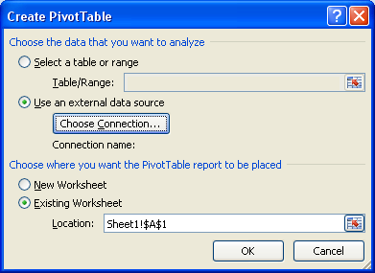

Select Use an external data source, choose connection, ‘browse for more’ and select the Orion access database and then dimArea Query.

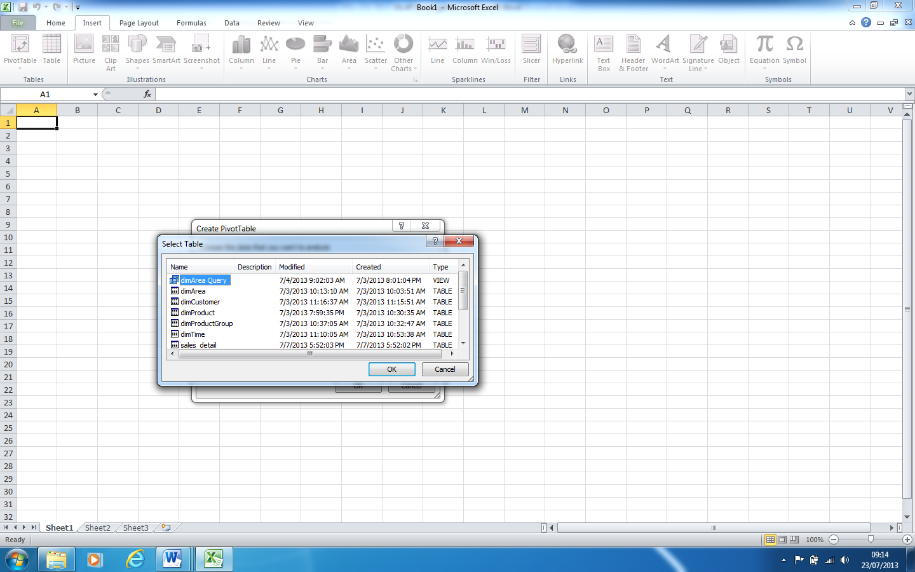

The spreadsheet will now have a skeleton pivot table in the top left of the spreadsheet and a data selection area on the right (as below).

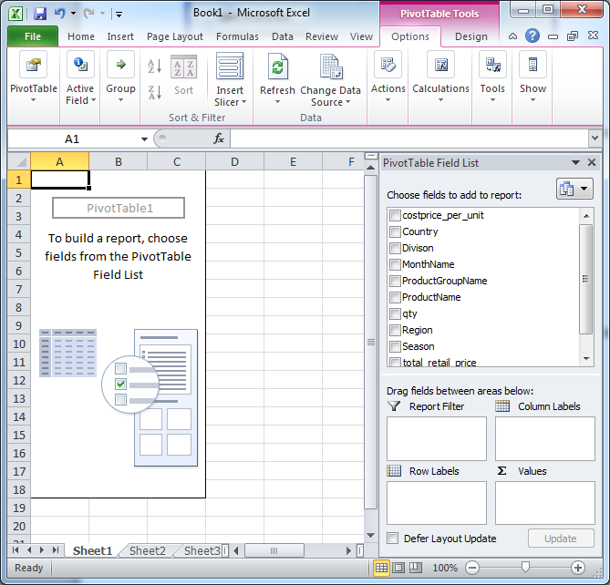

**Task 2: Explore and understand**

The 'Pivot Table Field List' (above right (top)) is the list of attributes which can be dropped into the spreadsheet, VIA the four empty white boxes underneath the field list. It is into these four boxes, that you will slowly add attributes. As you do this, those attributes and all the data associated with them, will appear in the spreadsheet to the left.

You need to perform the following actions, SLOWLY, step by step, so you can register what effect your actions have on the display of the data in the spreadsheet area. [Use the undo/do 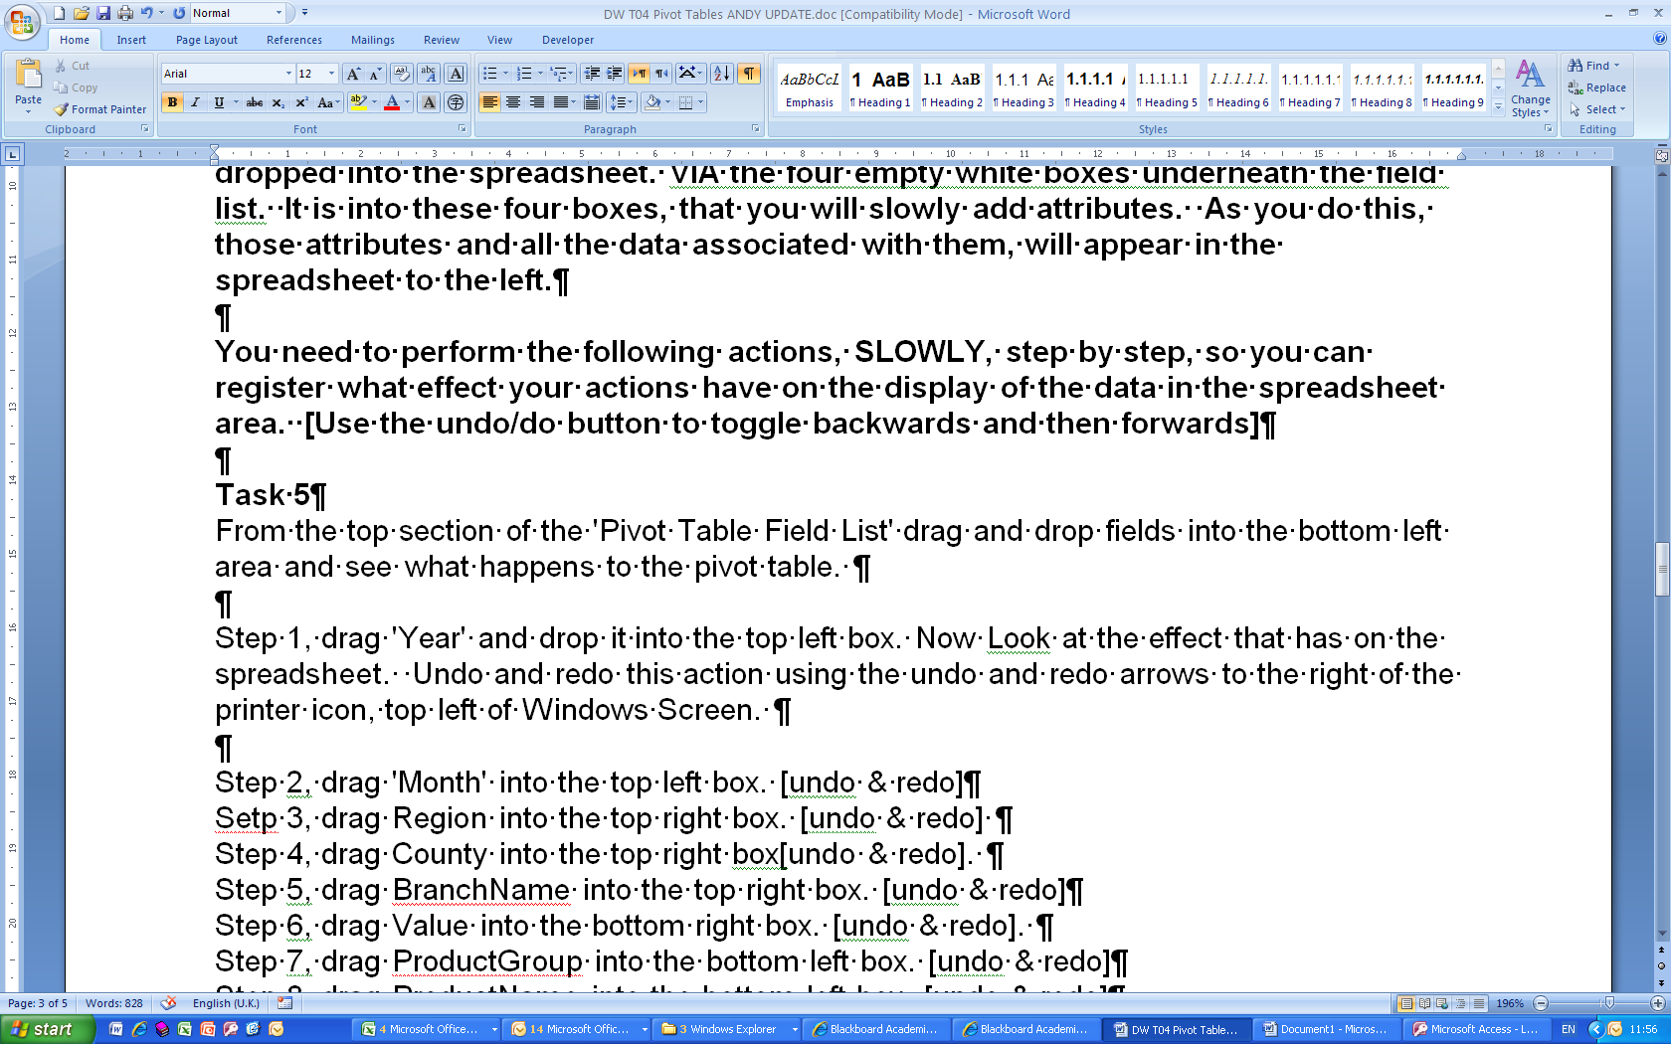 to toggle backwards and forwards a few times to embed in your understanding what effect your actions have]

Try this:

Step 1, drag 'Year' and drop it into the top left box. Now Look at the effect that has on the spreadsheet. Undo and redo  this action

Step 2, drag 'MonthName' into the top left box. [undo & redo  ]

Setp 3, drag ‘Country’ into the top right box. [undo & redo ]

Step 4, drag ‘Region’ into the top right box[undo & redo ].

Step 5, drag ‘Value’ into the bottom right box. [undo & redo ]

Step 6, drag ‘ProductGroupName’ into the bottom left box. [undo & redo ]

Step 7, drag ‘ProductName’ into the bottom left box. [undo & redo ]

By dragging and dropping fields into boxes, explore the data. Can you use the tool to find answer to typical analytical questions?

Explore the data by repeating the exercise above in reverse order. Does it work?

**Task 3: Try for yourself:**

Use the pivot table to answer questions. Such as:

* How many sales are there per productgroup (then drill down to see sales per product group per year).
* What are the sales like ‘season’ on ‘season’? again drill down to see sales per product group per season, then drill down again to see per product.
* Can you think of some of your own? Consider the design of dimensions and measures (and aggregates).

In order to do this exercise the access database had to be prepared – which we will do next. Be aware that PivotTables/PivotCharts are just about the most simple way of exploring and visualising the data.

Reading

1. ***Article Reviews***

Read and take notes on the following online articles:

<http://www.1keydata.com/datawarehousing/molap-rolap.html>

<http://www.donmeyer.com/art3.html>

<http://businessintelligence.ittoolbox.com/documents/document.asp?i=2934>

... and any others that you can find.

**OLAP Part 2– Preparing the database**

Open in Access the Orion database.

**Task 1: Familiarisation**

You will see:

* Dimension tables
* Fact tables
* Detail tables and
* Queries.

Step 1: Open up the tables and look at the data in them. They should be as you expect ( from your knowledge of data warehousing and star schema!). The ‘detail’ table is an unnormalised table containing all the data. Check out via ‘database tools’ and ‘relationship tools’ how the fact table and dimension tables are linked (again no surprises here).

Step 2: Double click on the dimArea query. You will see the data created when the query is run (note it is very similar to the detail table … interesting). Right click on the query and select design view.

**Task 2: Your turn – Dimension and FACT tables**

You have a table dimCustomer – which has the customers and information about them. You have the Sales_detail table which holds the sales per customer.

Step 1: Identify and create a customer_fact table with suitable measures. How will you work out the values for the measures?

FactCustomer(Customer_id, time_id, qty) (could have product_id, and others).

In the example all of these can be selected from sales_detail – so:

In Access, select Design Query, (right click on design query area (large grey area) and select Query Type/Make table Query). Then table name : FactCustomer, put sales_detail on the design page, select (double click) Customer_id, time_id, qty. Then Run the query. You now should have a table: FactCustomer

Note: How easy this was to do from the sales_detail. In an ETL script you might (cleanse data then) create a ‘detail’ table and use it or populate the FACT’s. OR you could populate the FACT’s by creating every combination of ids (cart-prod) and then update the measures of the FACT table from other tables using aggregate queries. OR INSERT into the FACT table with an SQL GROUP BY query. Probably the population of the FACT table will require a few well planned steps, and good SQL design to get the data you want.

I hope now you are realising the steps that may/will be required to get the data into a FACT table (the ETL script).

The customer fact table had the id created as datatype ‘text’ it needs changing to be in keeping with customer_dim

Step 2: Ensure the relationships are set up between PK’s and FK’s for the customer_fact and the dimCustomer.

Do this in query designer – it is probably automatically done as you drag them both over.

Step 3: Create a Query Customer_Qry to allow you to create support the analysis for customer.

If you have FactCustomer, dimCustomer and dimTime on the query design you can select (doubleclick) on: FactCustomer.time_id, dimTime. year, (and any others you may want), FactCustomer.customer_id, dimCustomer.name (and any others you may want), FactCustomer.qty

Save and Run this query as Customer_Qry

Step 4: Open up Excel, insert a pivot table linking to Customer_Qry and test it out. Review and Reflect.

**Task 3: Your Turn – the Detail table**

Can you insert as a pivot table the sales_detail directly? Maybe you need a query in Access ‘detail_qry’ which selects all from sales_detail. How does this work, is it useful? Is it as good as/better than using a star schema model? Can you think of limitations?

Also consider the dimensions, granularity of the dimension tables.